Creating a New Historical Academic Record
Created by Kristina Kelpe – June 30, 2025
In order to create an additional academic record for a historical student that already has an academic record in Workday, you have to use an EIB to load in the additional historical academic records. This document shows how to configure the EIB to load into Workday. For more documentation on EIBs in general, refer to separate documentation.
Step 1 - Generate the EIB with Data
- Go to View Integration System
- Select Put Historical Academic Record
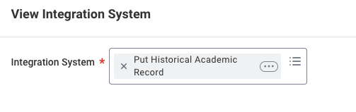
- Go into View of the Template Model using the steps in the screenshot:
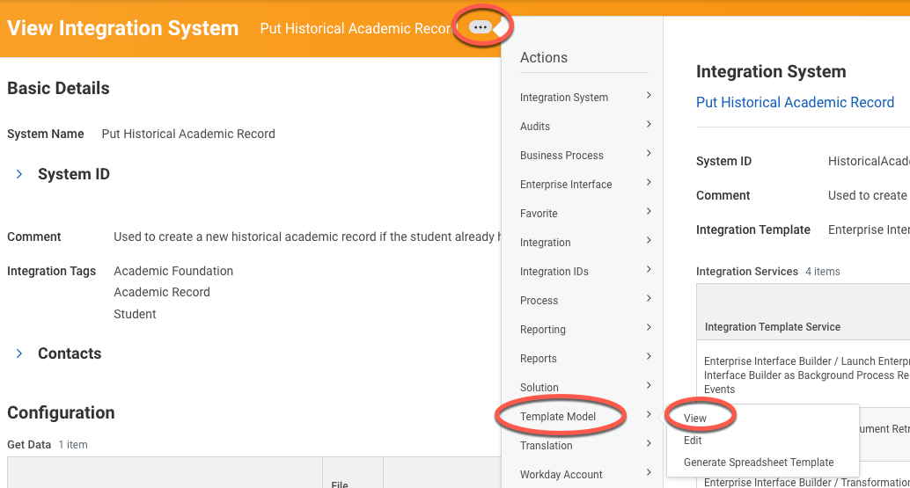
- Scroll to the bottom.
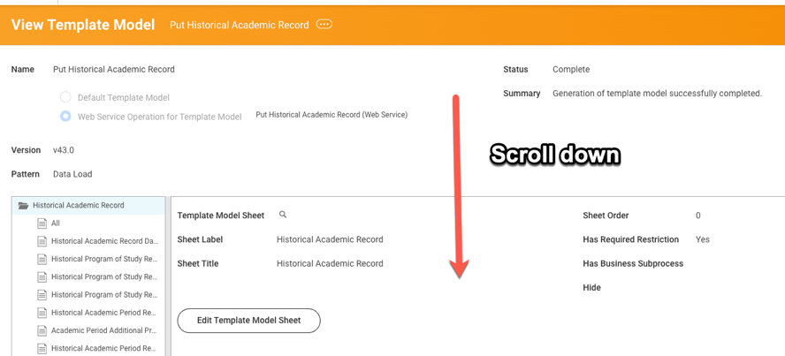
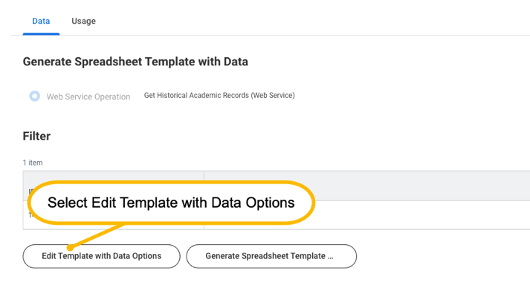
- Put in the Historical Academic Record Ref ID of the existing academic record:
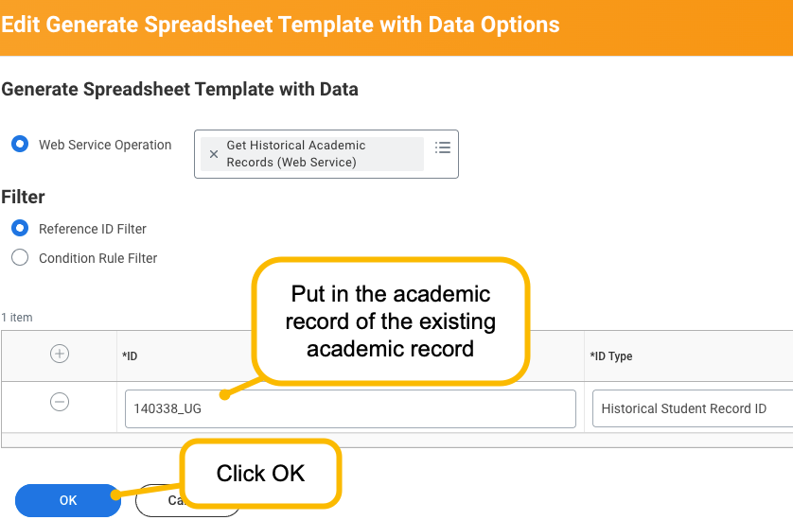

TIP: If you’re not sure what this is, follow these steps:
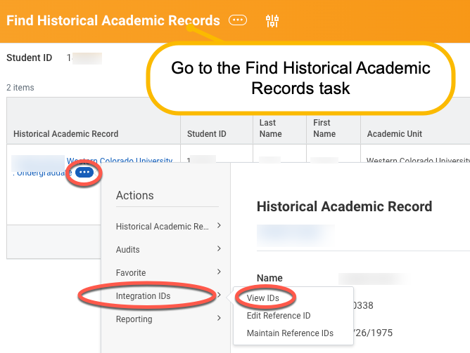

- Click Generate Spreadsheet Template
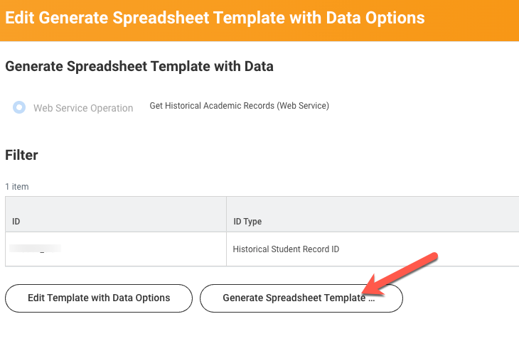
- Select the Generate Spreadsheet with Data
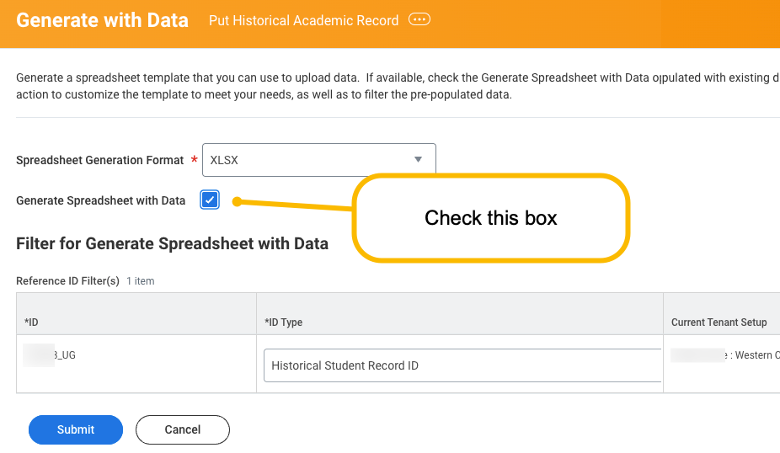
- Download your output file.
Step 2 – Update the Template
Use what data you can from the prior record; use as a template to fill out the data for the new academic record.
- Create a new Academic Record Ref ID
- Replace the Academic Level with the correct one
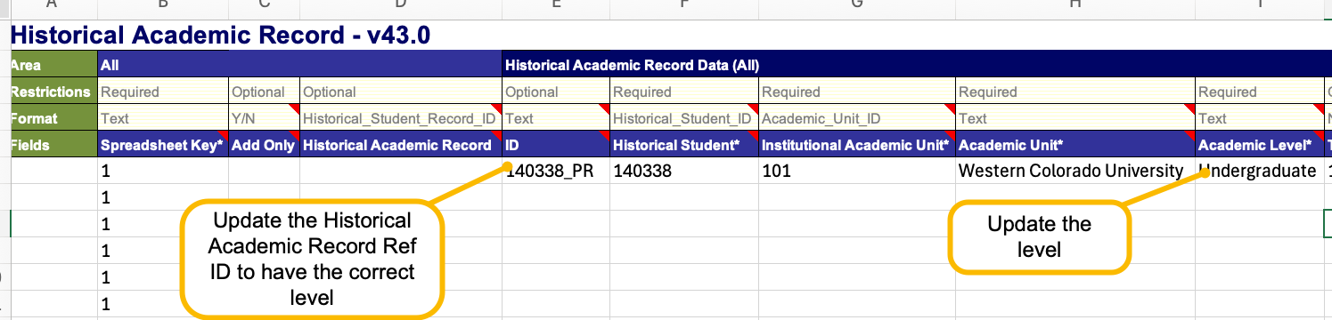
- Clear out fields that no longer apply.
- Use existing data as your template to figure out where data goes:
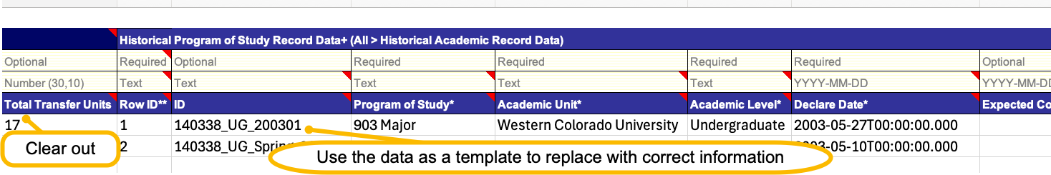
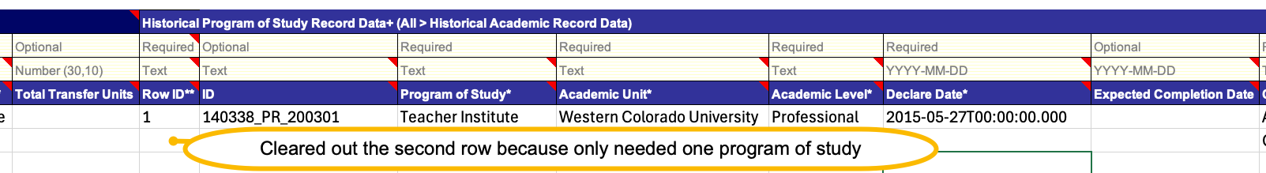
- Once you’ve replaced everything, go back to your Spreadsheet Key (Column B). Make sure you clear out any Spreadsheet Key where the row has no data.
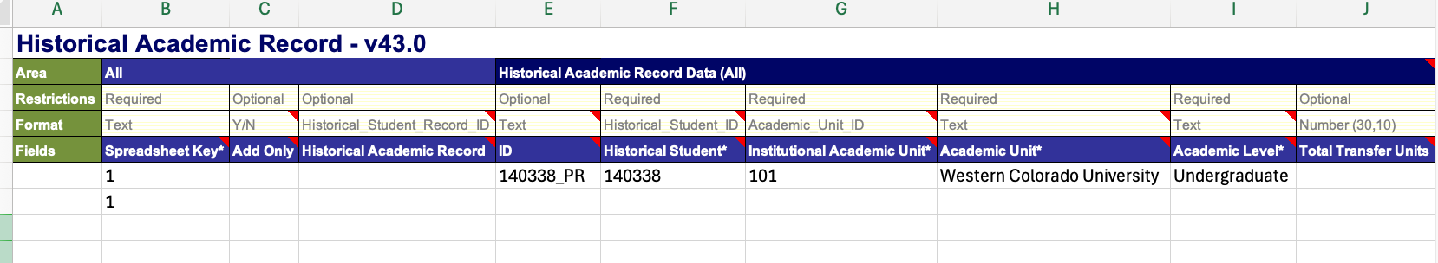
- Before you run in Sandbox, do a search in your file to make sure you replaced all your levels correctly.
- Run the EIB using your file in Sandbox.
- Go to Find Historical Academic Record to check and make sure the record looks accurate.

